**PROJECT REPORT TEMPLATE**

1. **Introduction**
   1. **Overview**

social media post is a short-form type of content or message that gets published on social media platforms such as Facebook, Instagram, Twitter, LinkedIn, and other similar channels. It takes several different forms that result from mixing text, images, videos, links, and A audio files

1.2 Purpose

 All in all, a post represents a piece of content that can easily be published across various social networks

1. Problem Definition& Design Thinking

* 1. EMPATHY MAP

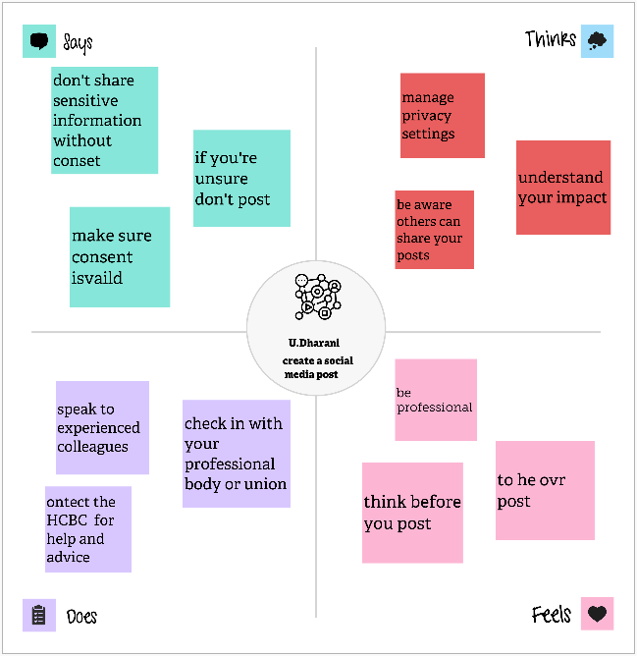

* 1. Brainstorming map

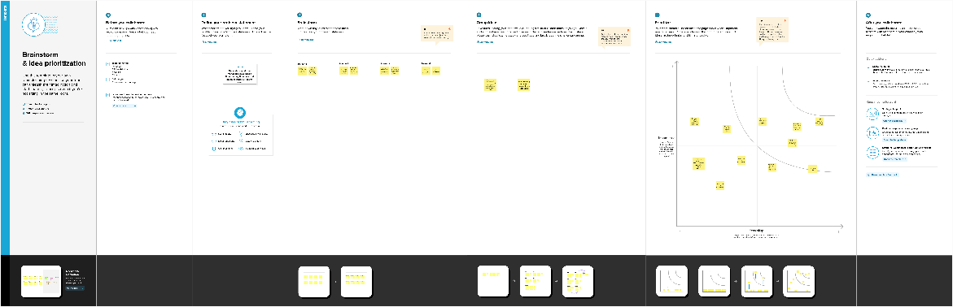

* 1. Result

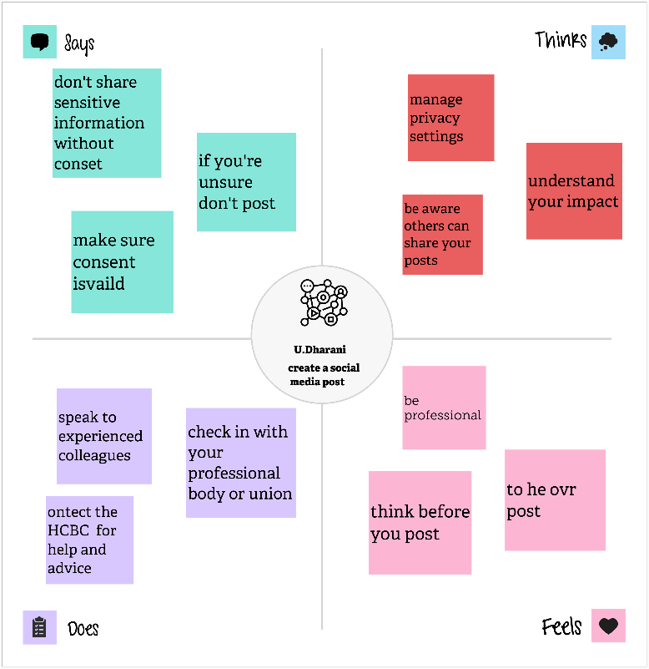



4 . Advantages

Filters are also fantastic for helping to keep your imagery on brand, creating your own signature stamp on all images that you upload to social. Canva lets you customize images with its easy to use image tools. Use the preset filter gallery or tweak your image to pixel perfection by using the image adjustment tools.

Disadvantage

You are dependent on Canva. It’s their platform and rightfully so. You aren’t licensing their software to create you own IP, you are simply using their platform to create content. Thus, Canva can delete your profile or your content at any time at their discretion.

5 .APPLICATION

1. Learn about your audience. Studying your audience can help you decide what types of posts will perform best. ...
2. Set goals. ...
3. Perform competitive analysis. ...
4. Gather content. ...
5. Develop a content creation plan. ...
6. Create a calendar. ...
7. Evaluate content.

6. CONCLUSION

Social media can make it easy to find groups of like-minded people or make new friends. Finding a close-knit community can help us feel valued and accepted. Social media is also an easy way to nurture existing relationships with family and friends who have moved

7.FUTURE SCOPE

The scope of social media is vast and constantly evolving. It can refer to a variety of platforms, including Facebook, Twitter, Instagram, Snapchat, LinkedIn, and Pinterest, as well as any other platform or app used to communicate with others, such as blogs, wikis, forums, video sharing sites, and virtual worlds.